

FACULTY OF TECHNOLOGY AND ENGINEERING
DEVANG PATEL INSTITUTE OF ADVANCE TECHNOLOGY
AND RESEARCH

DEPARTMENT OF COMPUTER ENGINEERING

A.Y 2026 – 27 Semester – 3

LAB MANUAL

CSUC201 Fundamentals of Data Structures and Algorithms

Practical 5: Doubly Linked List and Circular Linked List
Practical Aim
To implement core doubly linked list and circular linked list operations and understand how bidirectional and circular linking change the way nodes are inserted, deleted, and traversed.
Problem 1
A music player maintains a playlist where songs can be added to the beginning, added to the end, or inserted right after a specific song that is currently playing. When a song is removed, only the first song in the playlist is dropped. At any point the player can count how many songs are in the playlist and display them from first to last. Given a sequence of such operations, implement all of them on a doubly linked playlist and print the result after each operation.
Describe how your insertion after a given song works. What extra step does a doubly linked list require here that a singly linked list did not? What happens if the given song is not found in the playlist?
Theory:
1. A doubly linked list maintains two links per node instead of one. When deleting the front node, explain why having a backward link on the second node creates a responsibility that did not exist in a singly linked list — and what goes wrong if you forget to handle it.
When deleting the front node, the second node becomes the new head of the doubly linked list. Its backward link (prev) must be set to NULL because it no longer has a previous node. If we forget to update this link, the new head will still point to the deleted node, which can cause incorrect backward traversal and access to invalid memory.

Code:
https://github.com/kanan2007s-sys/FDSA_B/tree/main/Practical%201

Output Screenshot:
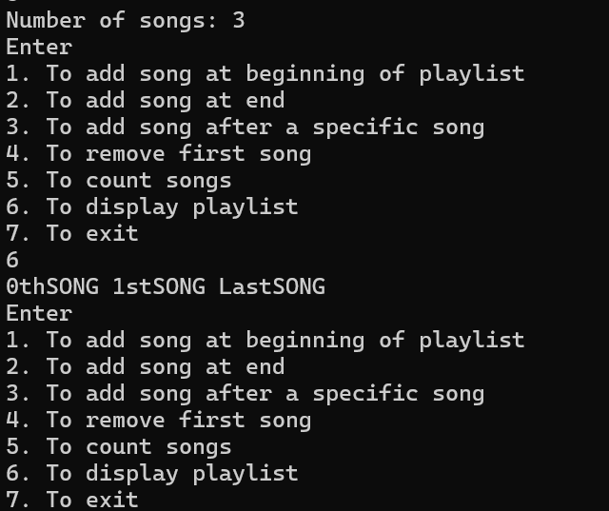

Description:
Implemented insertion at the beginning, end, and after a specific song in a doubly linked list.
Performed deletion of the first song, counting songs, and displaying the playlist.
Updated previous and next pointers correctly and handled cases where a song was not found.

Challenge:
I faced challenge in pointing the pointer to next song and adding the song in between of the playlist.

Problem 2
A group of students are sitting in a circle playing a passing game. A token starts at the first student and is passed around the circle one student at a time. Students can join the circle at any position and leave at any time, and the circle must remain unbroken after every join or leave. Given a sequence of join, leave, and display operations, implement them on both a singly circular and a doubly circular linked list and print the current circle after each operation.
Describe how your solution ensures the circle stays unbroken after a student leaves. What is the one case where breaking the circle is most likely to happen as a bug, and how did you handle it?
Theory:
2. If your traversal of the circular list does not stop at the right moment, it will loop forever. Without referencing any specific code, explain what condition must be true at the moment you stop, and why that condition would fail if you set the last node's link to null.
Traversal should stop when the pointer reaches the starting node again, which indicates that the complete circle has been visited once. The last node must point back to the first node instead of NULL. If its link is set to NULL, the circular structure breaks, and the list no longer forms a complete circle.
Code:
https://github.com/kanan2007s-sys/FDSA_B/tree/main/Practical%201

Screenshot:
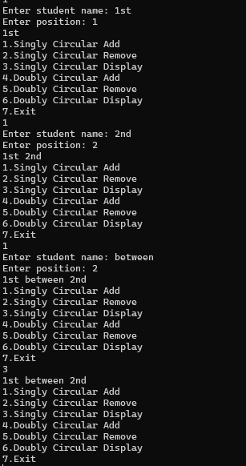
Description:
Implemented join, leave, and display operations using singly and doubly circular linked lists.
Maintained circular links between students after every insertion and deletion.
Handled empty and single-node circles to prevent broken links and infinite traversal.

Challenge:
I faced challenge in making the circular linked list , since it points in two directions so adding and removing element was difficult.
Conclusion:
Successfully implemented doubly and circular linked lists and understood pointer manipulation, insertion, deletion, and traversal.

